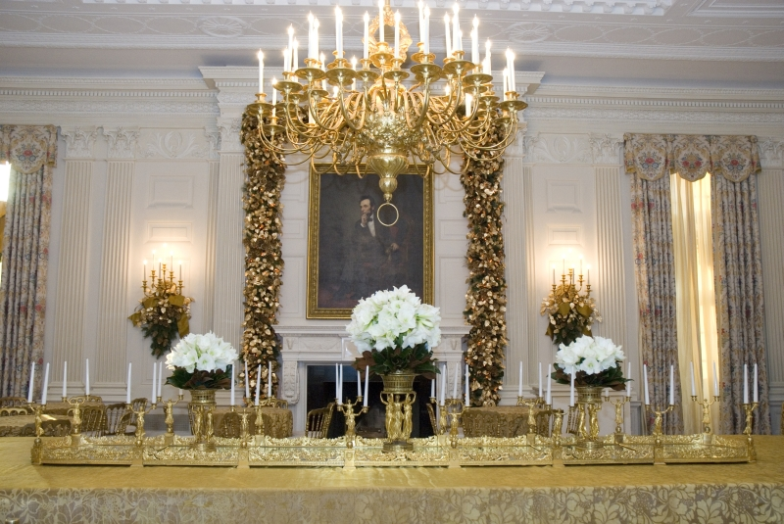
The Society for Mining, Metallurgy, and Exploration, Inc. – Washington, DC Section

invites you to a

Gala Holiday Dinner

Friday, December 11, 2009
6 pm to 10 pm

Fort Myer Officers’ Club
214 Jackson Avenue
Fort Myer, VA 22211

A silent auction will be held before and after dinner to benefit SME-DC outreach activities. Back by popular demand⎯Geo-pardy Quiz Show⎯in lieu of guest speaker.

Special Dinner Entrée: Filet Mignon & Chicken
Tournedo of Beef and Grilled Chicken Breast served with red wine and light butter sauces

includes House Salad, Vegetables,
Potatoes or Grains, Rolls & Butter, Key Lime Pie, Coffee, Tea, and Wine

RSVP
By November 30, please send the names  of attendees and a check for $50 per person payable to SME-DC to:  Lisa Corathers  989 National Center  U.S. Geological Survey  Reston, VA 20192 | Include your email address  for confirmation and directions.  Questions? Contact Lisa Corathers  by email, lcorathers@usgs.gov, or  by phone, 703-648-4973

